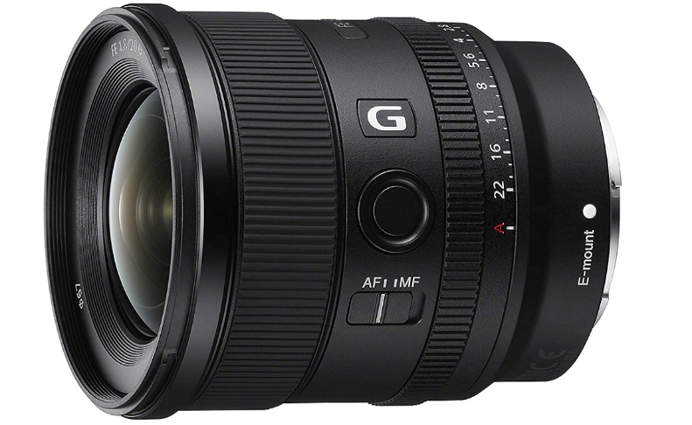

##### Sony FE 20mm F1.8

* **Compact ultra-wide prime G lens w/ stunning wide-open resolution**
* **F1.8 max aperture provides extraordinary exposure and depth of field**
* **Compact, lightweight design, ideal for both full-frame and APS-C2 cameras**
* **Advanced Aspheric elements for natural, lifelike high resolution**
* **Two XD Extreme Dynamic Linear motors for fast, precise autofocus**

**Price $1,229.00**